TASK 2

Дана таблица людей People. Поля: ID, FirstName, ParentName, LastName, ID_Father, ID_Mother.

Для всех Дмитриев выведите их ФИО и ФИО их отцов.

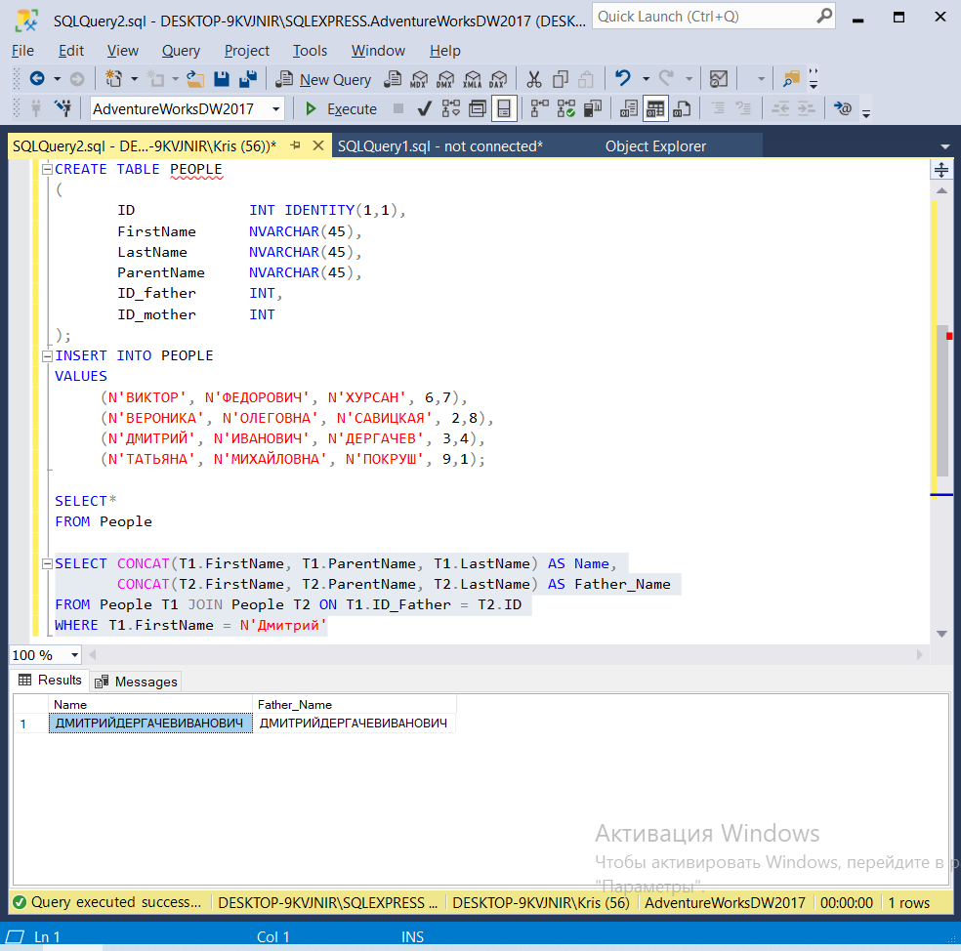

CREATE TABLE PEOPLE

(

ID INT IDENTITY(1,1),

FirstName NVARCHAR(45),

LastName NVARCHAR(45),

ParentName NVARCHAR(45),

ID_father INT,

ID_mother INT

);

INSERT INTO PEOPLE

VALUES

(N'ВИКТОР', N'ФЕДОРОВИЧ', N'ХУРСАН', 6,7),

(N'ВЕРОНИКА', N'ОЛЕГОВНА', N'САВИЦКАЯ', 2,8),

(N'ДМИТРИЙ', N'ИВАНОВИЧ', N'ДЕРГАЧЕВ', 3,4),

(N'ТАТЬЯНА', N'МИХАЙЛОВНА', N'ПОКРУШ', 9,1);

SELECT*

FROM People

SELECT CONCAT(T1.FirstName, T1.ParentName, T1.LastName) AS Name,

CONCAT(T2.FirstName, T2.ParentName, T2.LastName) AS Father_Name

FROM People T1 JOIN People T2 ON T1.ID_Father = T2.ID

WHERE T1.FirstName = N'Дмитрий'